NHS TRAVEL VACCINE ASSESSMENT FORM

**IMPORTANT INFORMATION**

THE PRACTICE NO LONGER PROVIDES A TRAVEL CLINIC SERVICE. WE ONLY PROVIDE PRESCRIPTIONS FOR VACCINES THAT ARE AVAILABLE ON THE NHS. YOU MAY HOWEVER, REQUIRE ADDITIONAL VACCINES OR ANTI MALARIA TABLETS THAT ARE NOT AVAILABLE ON THE NHS. WE DO NOT PROVIDE ANY ADVICE WITH REGARD TO ANY ADDITIONAL PRIVATE VACCINES OR ANTI MALARIA TABLETS THAT YOU MAY REQUIRE. IT IS YOUR RESPONSIBILITY TO CHECK THAT YOU ARE APPROPRIATELY VACCINATED AND TO SOURCE ANTI MALARIA TABLETS (IF REQUIRED) FOR YOUR UPCOMING HOLIDAY. WE RECOMMEND THAT YOU CONTACT A SPECIALIST TRAVEL CLINIC FOR FURTHER ADVICE AND TO UNDERGO A FULL PRE TRAVEL RISK ASSESSMENT.

Further Advice can be found at:

NaTHNaC - Country List (travelhealthpro.org.uk)

Travel Vaccines available on the NHS:
Hepatitis A, Typhoid, Tetanus, Diptheria, Polio, Cholera

Please complete the NHS travel vaccine assessment form, ideally 6 to 8 weeks before your travel date and return it to the Practice as some vaccines need to be given well in advance to allow your body to develop immunity.
You will be contacted if an NHS vaccination is required and has been issued, please allow a minimum of 5 working days for this. Ensure the surgery has an up to date contact phone number for you. Please remember to book a treatment room appointment for the administration of your vaccines if required.
If you do go to a travel clinic for additional vaccinations please inform reception so we can update your records.

Ormeau Health Centre

Pre Travel Risk Assessment Form

Name:

Date of Birth: | Male/Female
Date of travel:
Date of return:

Country to be visited  Area/Region | Length of stay
1.
2.
3.
4.
5.
6.
7.
8.

Personal Medical History:

Give details of any conditions which may affect your travel plans

Do you have any current or past medical conditions of any note e.g.
pregnancy, diabetes, heart or lung conditions, epilepsy, thymus disorders, cancer, HIV?
List any medication that you are taking

Do you have or have you ever had any of the following:

Allergies (e.g. eggs, antibiotics)
A previous reaction to any vaccine
Recent surgery
Treatment with steroids, chemotherapy or radiotherapy
High blood pressure
Epilepsy
Fainting
Anxiety, depression or mental illness

Vaccination history:

Please tick any travel vaccine that you have previously been given, (including any given by a private travel clinic) stating when.

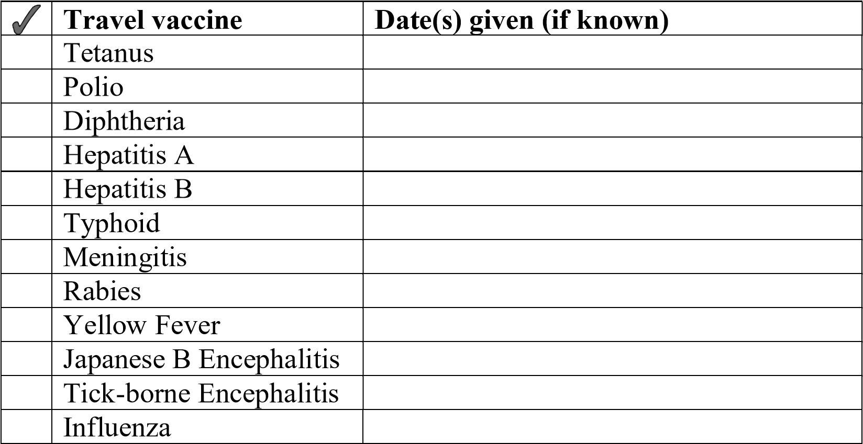

Please detail below any further information that you may feel might be relevant:

I am aware that this is not a full pre travel risk assessment and if I wish to receive vaccinations that are not available on the NHS or anti malaria tablets I must source these privately through a travel clinic or Community Pharmacy

Signed: ______________________ Date: _____________

